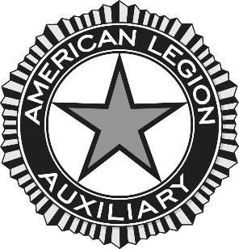

Report of Deceased Member

UNIT CHAPLAIN: Please make copies of this form for your use. Upon the death of a member, complete this report. Send a copy of this report and a “Member Data Form” to the Department. Please add the address of Next of Kin so our condolences can be sent. Thank you

Unit Name/Number: _______________________________ District: _____

Name of Deceased Member: ____________________________________

Date of Death: ____________________ (Please attach copy of obituary)

Next of Kin/Relationship: _______________________________________

Address: ____________________________________________________

Was she a Charter Member: ____ Sr. Member: _____ Jr.Member: ______ Past President: _____ Gold Star Mother: _____

Significant lnformation:
____________________________________________________________
____________________________________________________________

If you will add the information for the next of kin, the Chaplain will send them a card with the Auxiliary’s condolences.

American Legion Auxiliary
Department of Utah Chaplain
PO Box 148000
Salt Lake City, UT 84114-8000

