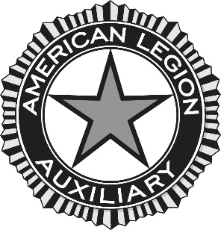

Information for Department Historian 2022-2023
Please send in information and pictures of the activities your Unit does through the year so we can prepare the Department President’s scrapbook and Department History. Tell the story of why you are a member of the American Legion Auxiliary.
Please send event information such as flyers, copies of any newspaper clippings, Unit newsletters, pictures, etc. You are welcome to send them at any time, you don’t have to wait until the end of the year.

American Legion Auxiliary
PO Box 148000
Salt Lake City, UT 84114-8000
alautah@yahoo.com

